1) Write a C program for this problem using array.

* 1. Ask the user to input values for float a[10] by using while-loop.
  2. In the same program, by using a do-while loop, compute and solve 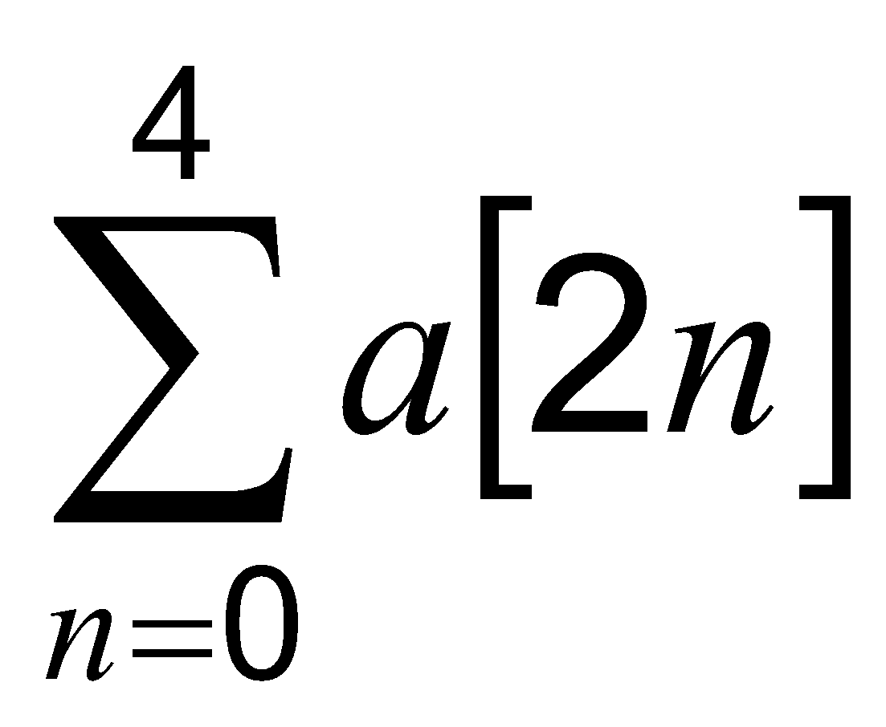  from a[10].

iii) Then by using a pre-test loop, compute and solve 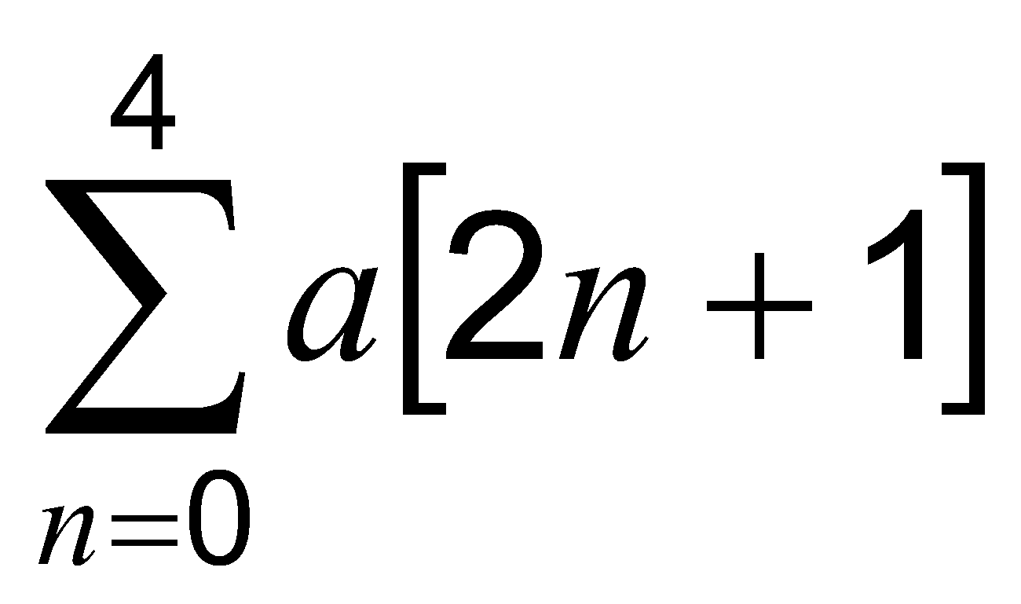 from

a[10].

Example

a[0] = 1.1

a[1] = 1.2

a[2] = 1.4

:

a[9] = 1.5

a[0] + a[2] + a[4]+ .....+ a[2n] = 1.1 + 1.4 + .... = ??

a[1] + a[3] + a[5]+....+ a[2n+1] = 1.2 + ..+1.5 = ??

Name

khairi

#include<stdio.h>

int main()

{

float a[10],sum,total=0,sum2=0,total2=0;

int i,n;

i=0;

while (i<10)

{

printf("Enter The Value For a[%d]= ",i);

scanf("%f",&a[i]);

i++;

}

i=0;

do

{

sum =a[(2*i)];

total = total + sum;

printf(" a[%d] ",(2*i));

if (i<4)

printf("+");

i++;

}

while (i<=4);

printf("=");

i=0;

do

{

printf("%.2f ",a[2*i]);

if (i<4)

printf("+");

i++;

}

while (i<=4);

printf("=");

printf(" %.2f\n",total);

for (i=0;i<=4;i++)

{

printf("a[%d] ",(2*i)+1);

if (i<4)

printf("+");

sum2 = a[(2*i)+1];

total2 =total2 + sum2;

}

printf("=");

for (i=0;i<=4;i++)

{

printf(" %.2f ",a[(2*i)+1]);

if (i<4)

printf("+");

}

printf("=");

printf(" %.2f",total2);

return 0;

}

anis

#include<stdio.h>

int main()

{

int i=0, n=0;

float a[10], sum_odd=0.0, sum_even=0.0;

while(i<10)

{

printf("Please Enter The Value of a[%d]\n", i);

scanf("%f", &a[i]);

i++;

}

do

{

sum_even+= a[2*n];

n++;

}while(n<=4);

printf("The Value of sum is %.2f\n", sum_even);

for(n=0;n<=4;n++)

{

sum_odd+= a[2*n+1];

}

printf("The Value of sum is %.2f\n", sum_odd);

return 0;

}

Elvis

#include<stdio.h>

#include<math.h>

int main()

{

float a[10],sum,total=0,sum2=0,total2=0;

int i,n;

i=0;

while (i<=9)

{

printf("Input for a[%d]= ",i);

scanf("%f",&a[i]);

i++;

}

i=0;

do

{

sum =a[(2*i)];

total = total + sum;

printf(" a[%d] ",(2*i));

if (i<4)

printf("+");

i++;

}

while (i<=4);

printf("=");

i=0;

do

{

printf("%.2f ",a[2*i]);

if (i<4)

printf("+");

i++;

}

while (i<=4);

printf("=");

printf(" %.2f\n",total);

i=0;

while (i<=4)

{

printf("a[%d] ",(2*i)+1);

if (i<4)

printf("+");

sum2 = a[(2*i)+1];

total2 =total2 + sum2;

i++;

}

printf("=");

i=0;

while(i<=4)

{

printf(" %.2f ",a[(2*i)+1]);

if (i<4)

printf("+");

i++;

}

printf("=");

printf(" %.2f",total2);

return 0;

}

2) The *Spectral Energy* of a bound-state Hydrogen atom restricted to 2-dimensional plane is given by the equation 

where *n* are *positive integers*, *e* is the *elementary charge*, eo is the *permittivity constant* in free space, and *aB* is the Bohr Radius. *En* unit is in eV (electron Volt).

Write a C program to compute the *Spectral Energy, En* of the atom for each value of *n*, with the maximum *n* = 50.

For each value of *n*, your program must report the corresponding energy in the scientific notation format by using the format specifier %le. Use **1D**-**array to store the answers for the *Spectral Energy, En.***

where *e* = 1.602177 x 10 -19 C, eo = 8.854187 x 10-12 Fm-1, *aB*= 5.291772 x10 -11 m

Name

Irfan :

#include<stdio.h>

#include<math.h>

#define e 1.602177E-19

#define eo 8.854187E-12

#define aB 5.291772E-11

#define pi 3.141592653589793238

double calc(int i, double k);

int main()

{

int i;

double En[50], k;

k = (e*e)/(4*pi*eo);

for(i=0;i<51;i++)

{

En[i]=calc(i,k);

}

for(i=0;i<51;i++)

{

printf("En[%d] \t= %EeV\n", i, En[i]);

}

return 0;

}

double calc(int i, double k)

{

return -1*k/(2*aB*pow((i+0.5),2));

}

Ahmad Hakim ?

3. Construct a full C code to solve the problem given below in one program. The number of elements (*n*) and elements of the array is given by the user.

| Operation | Definition | Example |
| --- | --- | --- |
| Matrix Addition | A + B | *n*=5 , [2 8 9 7 8] + [7 3 0 7 7] = [9 11 9 14 15] |
| Matrix Subtraction | C - D | *n*=2 |
| Matrix Multiplication | k*C | n=2, scalar, k=5 |
| Matrix Division | D/k | n=2, scalar, k=2 |

Rahmah

#include<stdio.h>

#include<math.h>

int main()

{

int elements,i,operation,k;

float num[i],num1[i],total[i];

printf("enter how many number do you want :"); //user elements

scanf("%d",&elements);

for(i=0;i<elements;i++) //looping for user input

{

printf("num[%d] = ",i);

scanf("%f",&num[i]);

}

printf("\n\n\n\n");

for(i=0;i<elements;i++) //looping for user input

{

printf("num1[%d] = ",i);

scanf("%f",&num1[i]);

}

//user choose the operation

printf("\n\n\n\n");

printf("please choose the operation\n");

printf("enter 1 if you choose addition\n");

printf("enter 2 if you choose subtraction\n");

printf("enter 3 if you choose multiplication\n");

printf("enter 4 if you choose division\n");

scanf("%d",&operation);

//operation

if(operation==1)//addition

{

for(i=0;i<elements;i++)

{

total[i]=num[i]+num1[i];

printf("the result is %.2f\n",total[i]);

}

}

else if(operation==2)//substraction

{

for(i=0;i<elements;i++)

{

total[i]=num[i]-num1[i];

printf("the result is %.2f\n",total[i]);

}

}

else if(operation==3)//product

{

printf("please insert scalar k");

scanf("%d",&k);

for(i=0;i<elements;i++)

{

total[i]=k*num1[i];

printf("the result is %.2f\n",total[i]);

}

}

else if(operation==4)//division

{

printf("please insert scalar k");

scanf("%d",&k);

for(i=0;i<elements;i++)

{

total[i]=num[i]/k;

printf("the result is %.2f\n",total[i]);

}

}

else

printf("sorry your input is not available");

goto again;

//goto label

again:

scanf("%d",&operation);

return 0;

}

Insyirah

#include<stdio.h>

#include<math.h>

int main()

{

int i,j,operation;

choose:

printf("Choose an Operation\n 1. Addition\n 2. Subtraction\n 3. Multiplication\n 4. Division\n");

scanf("%d", &operation);

if(operation < 1 || operation >4)

{printf("CHOOSE CAREFULLY\n");

goto choose;}

printf("\n");

printf("Input number of data\n");

scanf("%d", &j);

float k, a[j], b[j], add[j], minus[j], times[j], div[j];

switch(operation)

{

case 1: for(i=0;i<j;i++)

{

printf("Insert The Value of: a[%d] and b[%d]\n", i, i);

scanf("%f %f", &a[i], &b[i]);

}

for(i=0;i<j;i++)

{

add[i]= a[i] + b[i];

printf("Sum[%d] is : %.0f\n", i, add[i]);

}

break;

case 2:for(i=0;i<j;i++)

{

printf("Insert The Value of: a[%d] and b[%d]\n", i, i);

scanf("%f %f", &a[i], &b[i]);

}

for(i=0;i<j;i++)

{

minus[i]= a[i] - b[i];

printf("Substraction[%d] is : %.0f\n", i, minus[i]);

}

break;

case 3: for(i=0;i<j;i++)

{

printf("Insert value of: a[%d]\n", i);

scanf("%f", &a[i]);

}

printf("What is the scalar value\n");

scanf("%f", &k);

for(i=0;i<j;i++)

{

times[i]= a[i]*k;

printf("Multiplication[%d] is : %.2f\n", i,times[i]);

}

break;

case 4: for(i=0;i<j;i++)

{

printf("Insert value of: a[%d]\n", i);

scanf("%f", &a[i]);

}

printf("What is the scalar value\n");

scanf("%f", &k);

for(i=0;i<j;i++)

{

div[i]= a[i]/k;

printf("Division[%d] is : %.2f\n", i,div[i]);

}

break;

}

return 0;

}

khaleeda

#include<stdio.h>

int main()

{

int i,j,opt;

printf("Please Choose an Operation\n1. Addition\n2. Subtraction\n3. Multiplication\n4. Division\n");

scanf("%d", &opt);

if(opt < 1 ||opt>4)

{printf("ERROR\n"); return 0;}

printf("Please input the size\n");

scanf("%d", &j);

float k, a[j], b[j], sum[j], subs[j], multi[j], div[j];

switch(opt)

{

case 1: for(i=0;i<j;i++)

{

printf("Insert The Value of: a[%d] and b[%d]\n", i, i);

scanf("%f %f", &a[i], &b[i]);

}

for(i=0;i<j;i++)

{

sum[i]= a[i] + b[i];

printf("Sum[%d] is : %.0f\n", i, sum[i]);

}

break;

case 2:for(i=0;i<j;i++)

{

printf("Insert The Value of: a[%d] and b[%d]\n", i, i);

scanf("%f %f", &a[i], &b[i]);

}

for(i=0;i<j;i++)

{

subs[i]= a[i] - b[i];

printf("Subs[%d] is : %.0f\n", i, subs[i]);

}

break;

case 3: for(i=0;i<j;i++)

{

printf("Insert The Value of: a[%d]\n", i);

scanf("%f", &a[i]);

}

printf("What is the scalar value\n");

scanf("%f", &k);

for(i=0;i<j;i++)

{

multi[i]= a[i]*k;

printf("Multi[%d] is : %.2f\n", i,multi[i]);

}

break;

case 4: for(i=0;i<j;i++)

{

printf("Insert The Value of: a[%d]\n", i);

scanf("%f", &a[i]);

}

printf("What is the scalar value\n");

scanf("%f", &k);

for(i=0;i<j;i++)

{

div[i]= a[i]/k;

printf("div[%d] is : %.2f\n", i,div[i]);

}

break;

}

return 0;

}

4. Write a program in C to merge two arrays of the same size sorted in descending order.

Expected Output:

Input the number of elements to be stored in the arrays :3

Input 3 elements in the first array :

element - 0 : 1

element - 1 : 2

element - 2 : 3

Input 3 elements in the second array :

element - 0 : 1

element - 1 : 2

element - 2 : 3

The merged array in descending order is :

3 3 2 2 1 1

Name:

IDLAN Danish IKHZAM

IDLAN

#include <stdio.h>

void main()

{

int arr1[100], arr2[100], arr3[200];

int s1, s2, s3;

int i, j, k;

printf("\n\nMerge two arrays of same size sorted in descending order.\n");

printf("------------------------------------------------------------\n");

printf("Input the number of elements to be stored in the first array :");

scanf("%d",&s1);

printf("Input %d elements in the array :\n",s1);

for(i=0;i<s1;i++)

{

printf("element - %d : ",i);

scanf("%d",&arr1[i]);

}

printf("Input the number of elements to be stored in the second array :");

scanf("%d",&s2);

printf("Input %d elements in the array :\n",s2);

for(i=0;i<s2;i++)

{

printf("element - %d : ",i);

scanf("%d",&arr2[i]);

}

/* size of merged array is size of first array and size of second array */

s3 = s1 + s2;

/*----------------- insert in the third array------------------------------------*/

for(i=0;i<s1; i++)

{

arr3[i] = arr1[i];

}

for(j=0;j<s2; j++)

{

arr3[i] = arr2[j];

i++;

}

/*----------------- sort the array in decending order ---------------------------*/

for(i=0;i<s3; i++)

{

for(k=0;k<s3-1;k++)

{

if(arr3[k]<=arr3[k+1])

{

j=arr3[k+1];

arr3[k+1]=arr3[k];

arr3[k]=j;

}

}

}

/*--------------- Prints the merged array ------------------------------------*/

printf("\nThe merged array in decending order is :\n");

for(i=0; i<s3; i++)

{

printf("%d ", arr3[i]);

}

printf("\n\n");

return 0;

}

IKHZAM

#include <stdio.h>

int main()

{

int arr1[50], arr2[50], arr3[100];

int a1, a2, a3;

int i, j, k;

printf("Merge two arrays of same size sorted in descending order.\n");

printf("**************************************************************\n");

printf("Input number of elements to be stored in the 1st array :");

scanf("%d",&a1);

printf("Input %d elements in the array :\n",a1);

for(i=0;i<a1;i++)

{

printf("element - %d : ",i);

scanf("%d",&arr1[i]);

}

printf("Input number of elements to be stored in the 2nd array :");

scanf("%d",&a2);

printf("Input %d elements in the array :\n",a2);

for(i=0;i<a2;i++)

{

printf("element - %d : ",i);

scanf("%d",&arr2[i]);

}

a3 = a1 + a2;

for(i=0;i<a1; i++)

{

arr3[i] = arr1[i];

}

for(j=0;j<a2; j++)

{

arr3[i] = arr2[j];

i++;

}

for(i=0;i<a3; i++)

{

for(k=0;k<a3-1;k++)

{

if(arr3[k]<=arr3[k+1])

{

j=arr3[k+1];

arr3[k+1]=arr3[k];

arr3[k]=j;

}

}

}

printf("\nThe merged array in decending order is :\n");

for(i=0; i<a3; i++)

{

printf("%d ", arr3[i]);

}

printf("\n\n");

}

DZ

#include <stdio.h>

int main()

{

int e1[100], e2[100], e3[100];

int s,merge;

int i, j, k;

printf("Input the number of elements to be stored for both array :");

scanf("%d",&s);

printf("Input %d elements in the first array :\n",s);

for(i=0;i<s;i++)

{

printf("element - %d : ",i);

scanf("%d",&e1[i]);

}

printf("Input %d elements in the second array :\n",s);

for(i=0;i<s;i++)

{

printf("element - %d : ",i);

scanf("%d",&e2[i]);

}

merge = s + s;

for(i=0;i<s; i++)

{

e3[i] = e1[i];

}

for(j=0;j<s; j++)

{

e3[i] = e2[j];

i++;

}

for(i=0;i<merge; i++) //desc

{

for(k=0;k<merge-1;k++)

{

if(e3[k]<=e3[k+1])

{

j=e3[k+1];

e3[k+1]=e3[k];

e3[k]=j;

}

}

}

printf("\nThe merged array in descending order is :\n");

for(i=0; i<merge; i++)

{

printf("%d ", e3[i]);

}

printf("\n\n");

}